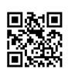
Read Call Numbers

Libraries use classification systems to organize the books and videos on the shelves. Most public libraries use the Dewey Decimal Classification System (DDC) and most academic libraries (including Reynolds Libraries) use the Library of Congress Classification System (LC).

You may be more familiar with the Dewey Decimal system, which uses only numbers to arrange materials on the shelves. The LC system uses a combination of letters and numbers to arrange materials on the shelves.

These classification systems allow each book and video in the library to be assigned a unique call number. A call number is like an address; it indicates where the book is located on the library shelves.

Anatomy of a Call Number

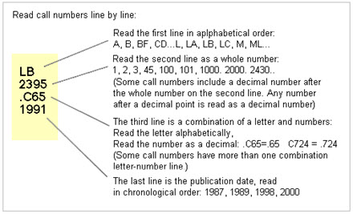

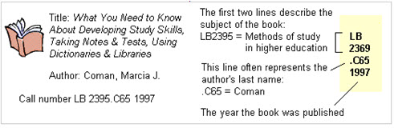

Created by Reynolds Community College Libraries. This work is licensed under a Creative Commons Attribution-NonCommercial-ShareAlike 4.0 International License.
Last updated 7/11/2018. Last reviewed 8/5/2019.

A call number label is attached to each book and video spine or front cover. Every item record in the library catalog also includes a call number. When searching the library catalog (Reynolds Libraries use Primo), you want to be sure to jot down the complete LC call number in order to locate the item on the shelf.
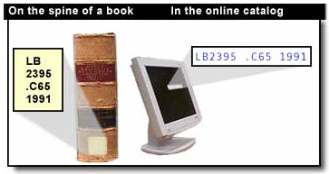
If you have a general subject in mind, you can also browse the shelves if you know the beginning Library of Congress classification letters for that subject (e.g., BF – Psychology books; L - Education; PS – American Literature; R – Medicine). Since materials are arranged by subject, browsing books located closely on the shelf can also yield results.
