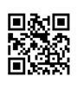



**Interpret Citations**

A citation is a reference to a source of information. A citation typically includes enough identifying information (e.g., author, title, publisher, publication date, database, DOI #) for a reader to be able to locate a copy of the item. The ability to interpret citations from various information sources is a fundamental research skill. In order to be able to correctly cite a source in a specific style (e.g., APA, MLA), you need to be able to determine what type of source the item is, where the source came from, and identify the various elements of the source. The following are some examples of common source types.

**Print Book – Library Catalog**

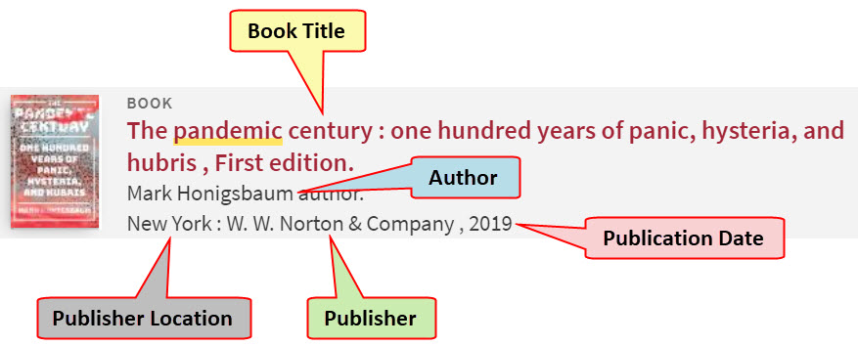

**Chapter in an eBook – Library Database**

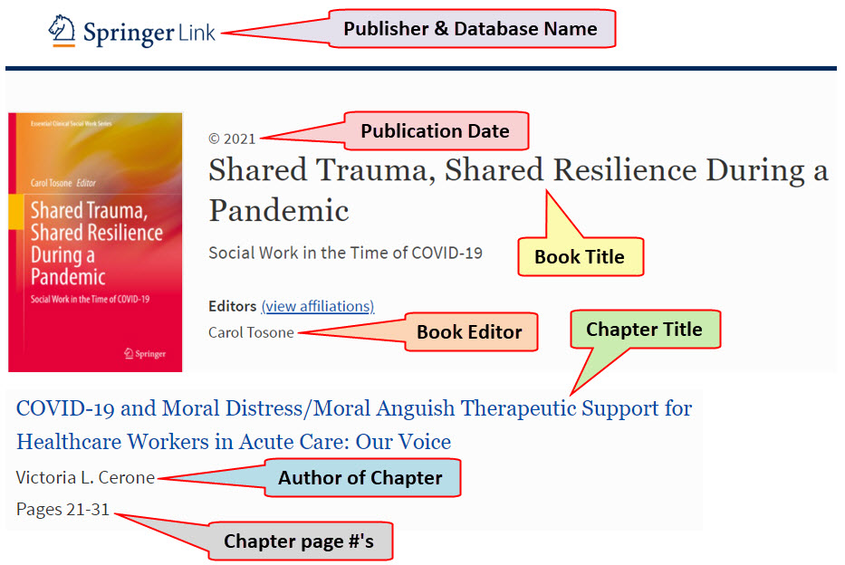

### http://mirrors.creativecommons.org/presskit/buttons/88x31/png/by-nc-sa.png

### *Created by Reynolds Community College Libraries. This work is licensed under a Creative Commons Attribution-NonCommercial-ShareAlike 4.0 International License. Last updated 6/4/2021.*

*Publisher*

**Journal Article – Library Database**

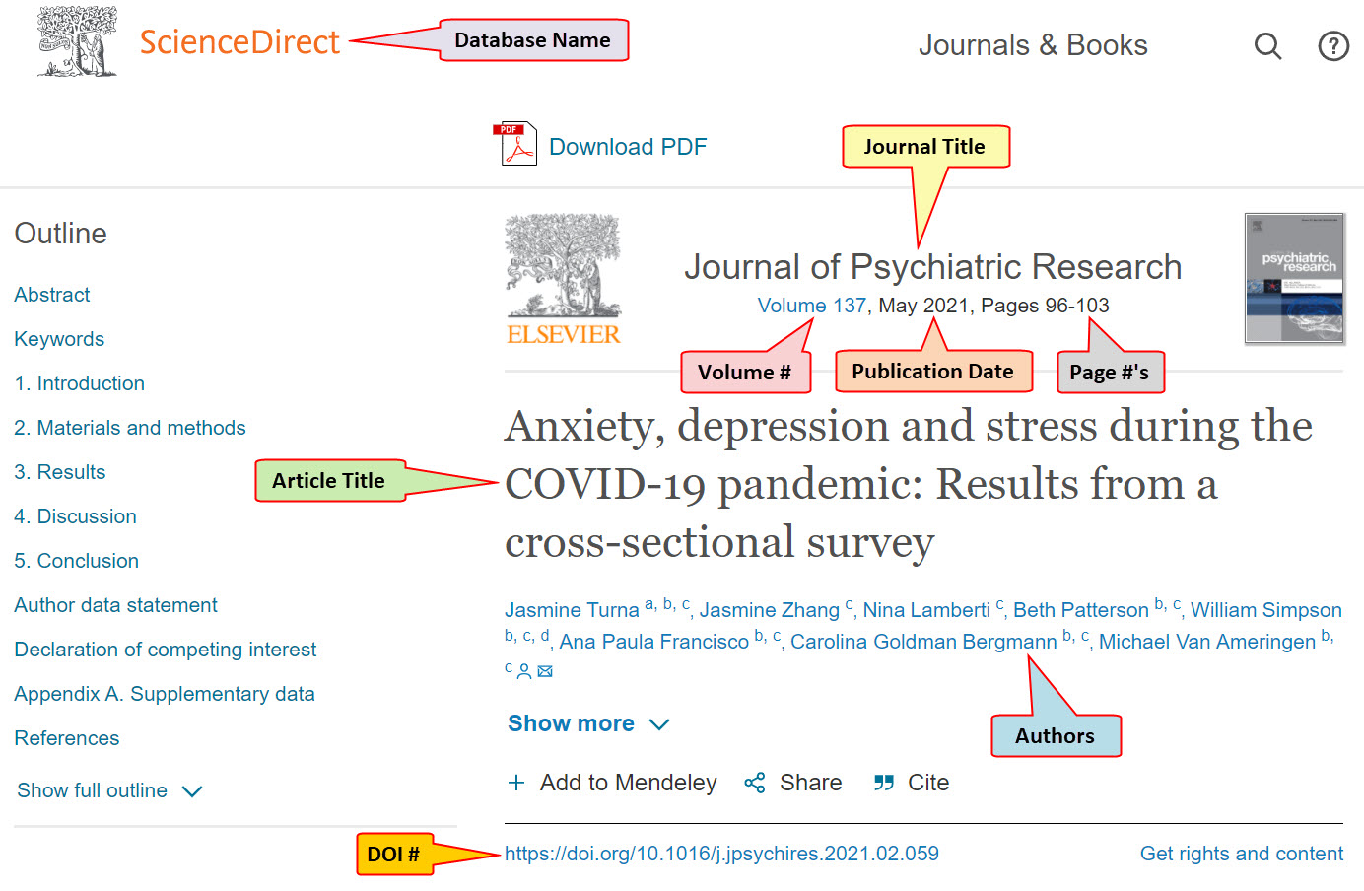

**Magazine Article – Library Database**

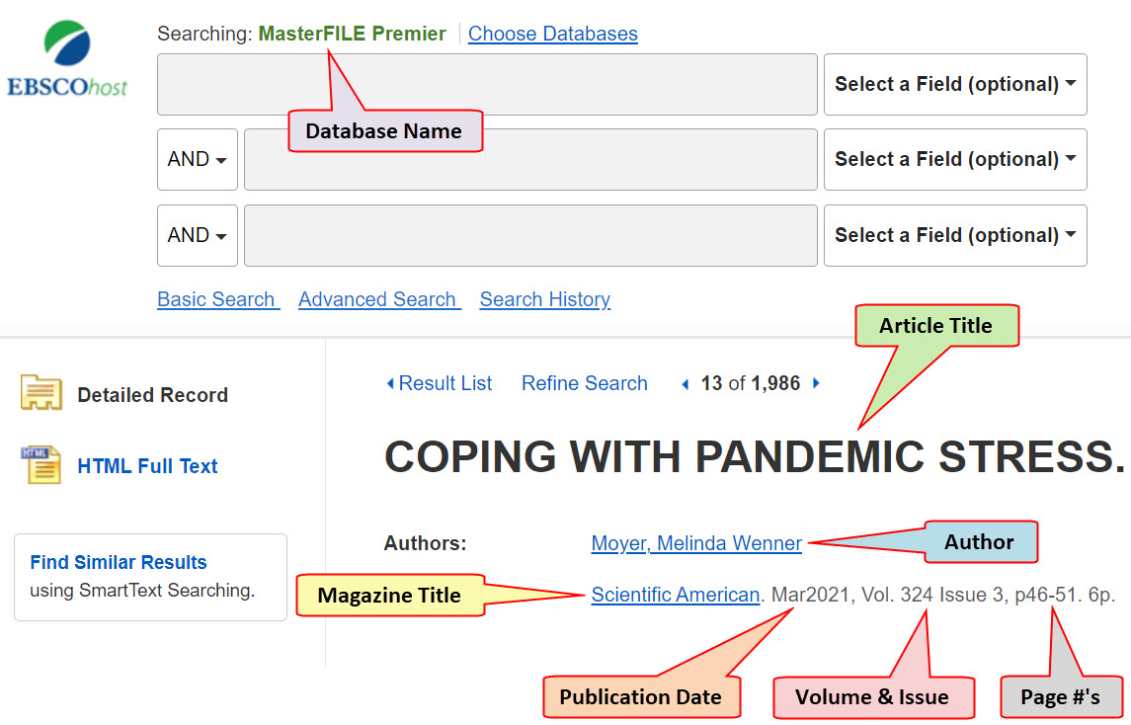

**Newspaper Article – Open Web**

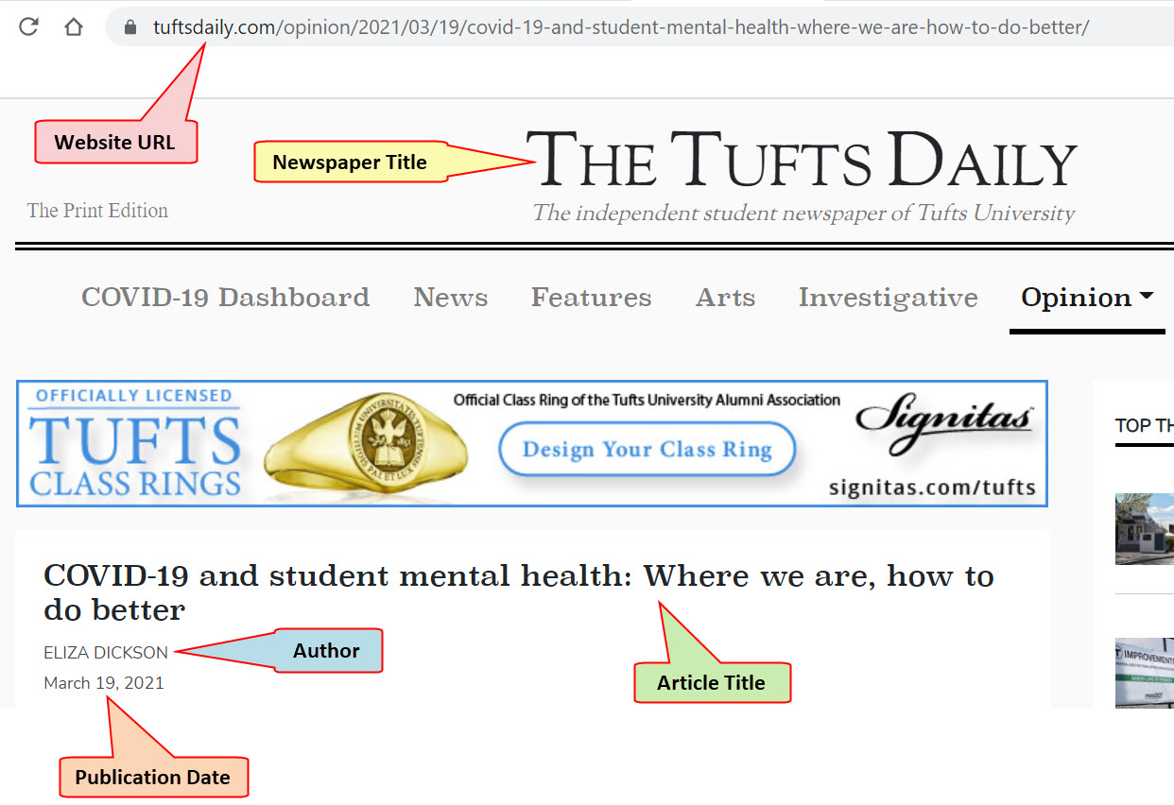

**Government News Release – Open Web**

