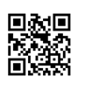
Interpret Citations Worksheet

Review the resource images below and identify the citation parts for each image.
Print Book by - Record from the Library Catalog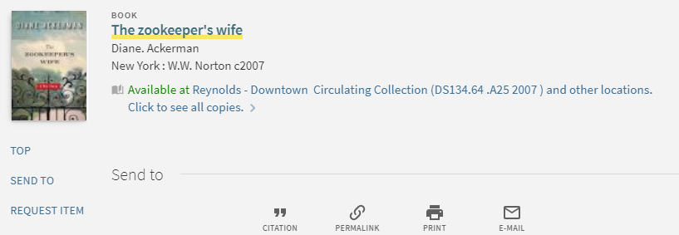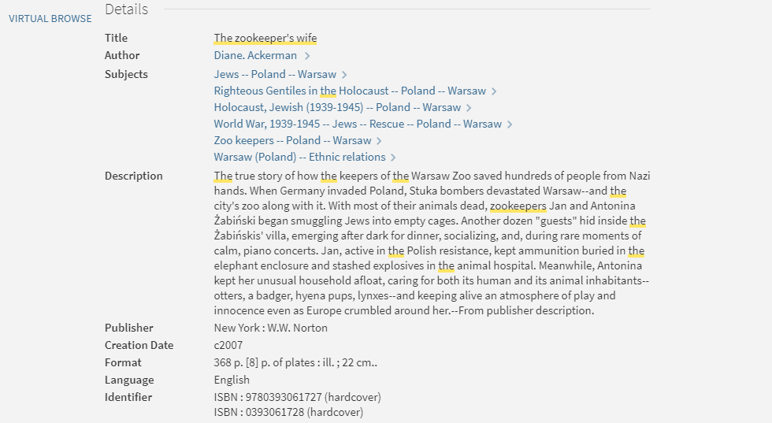
Authors: Click or tap here to enter text.
Book Title: Click or tap here to enter text.
Publisher Name: Click or tap here to enter text.
Publication Year: Click or tap here to enter text.

Created by Reynolds Community College Libraries. This work is licensed under a Creative Commons Attribution-NonCommercial-ShareAlike 4.0 International License.
Last updated 8/31/2018. Last reviewed 7/31/2019.

Online Journal Article – Retrieved from a Library Database
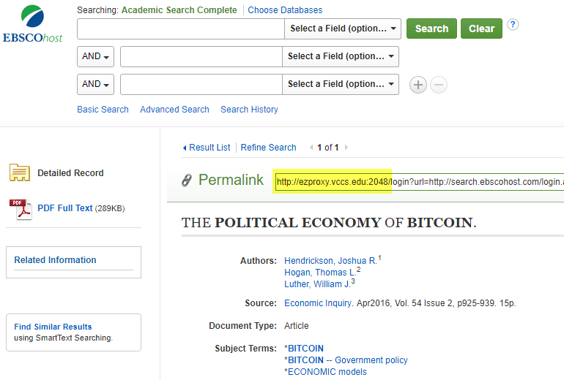
Article Title: Click or tap here to enter text.
Authors: Click or tap here to enter text.
Journal Title: Click or tap here to enter text.
Volume #: Click or tap here to enter text. Issue #: Click or tap here to enter text.
Publication Year: Click or tap here to enter text.
Starting and Ending Page #’s: Click or tap here to enter text.
Name of Database: Click or tap here to enter text.
Main URL of permalink: Click or tap here to enter text.

Online Magazine Article – Retrieved from a Library Database
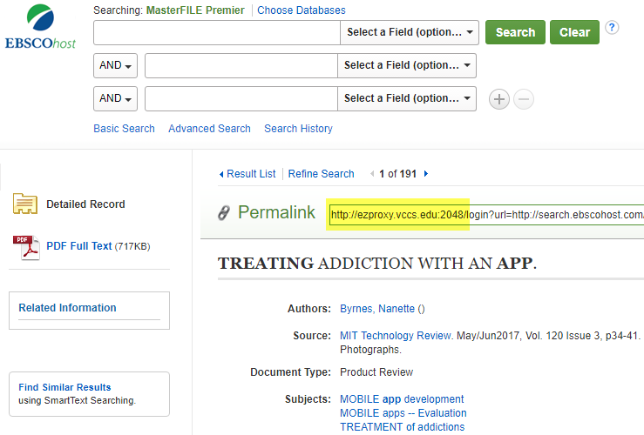

Article Title: Click or tap here to enter text.
Author: Click or tap here to enter text.
Journal Title: Click or tap here to enter text.
Volume #: Click or tap here to enter text. Issue #: Click or tap here to enter text.
Publication Date: Click or tap here to enter text.
Starting and Ending Page #’s: Click or tap here to enter text.
Name of Database: Click or tap here to enter text.
Main URL of permalink: Click or tap here to enter text.

Online Newspaper Article from a Website

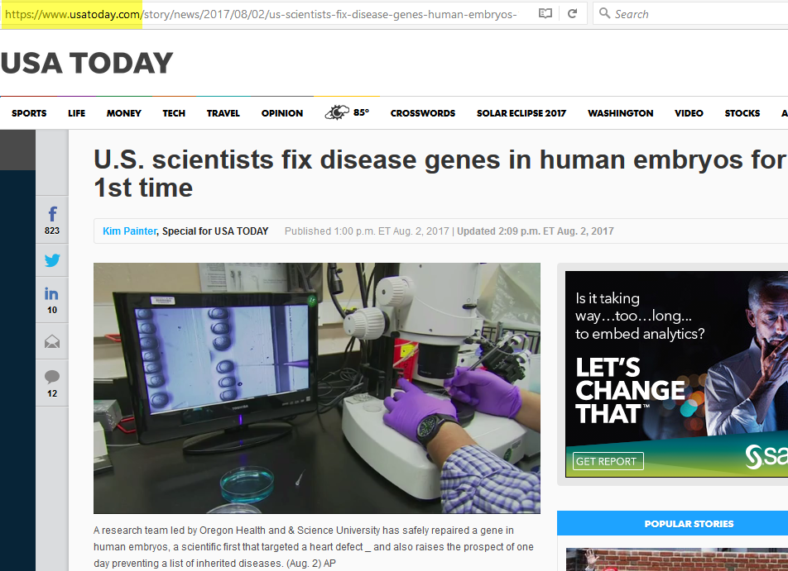

Article Title: Click or tap here to enter text.
Author: Click or tap here to enter text.
Publication Date: Click or tap here to enter text.
Newspaper Title: Click or tap here to enter text.
Main URL of the website: Click or tap here to enter text.

