Library Databases vs. the Open Web Worksheet

Use Google and the Academic Search Complete library database to search the topic pet therapy and compare the type of information found from each resource.
- Search Google
- Go to Google at http://www.google.com.
- Type pet therapy in the Google search box. Press the <Enter> key or click on the Google Search button to execute the search.
- When the Google Results screen appears, click on and briefly review the first 5 web sites.

- Search for full-text articles in the Academic Search Complete database
    - Go to the Reynolds Libraries homepage at http://library.reynolds.edu.
    - Mouse your mouse over Quick Links located near the upper right side of the screen. When the Quick Links menu appears, click on Academic Search Complete. If you are accessing the database from off-campus, you will be prompted to login with your My Reynolds username and password.
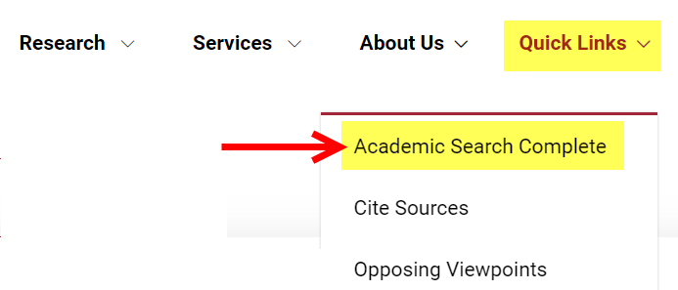

    - When the Academic Search Complete search screen appears, type pet therapy in the search box. Also, limit your search to Full text articles published within the last 5 years. Press the <Enter> key or click on the Search button to execute the search.

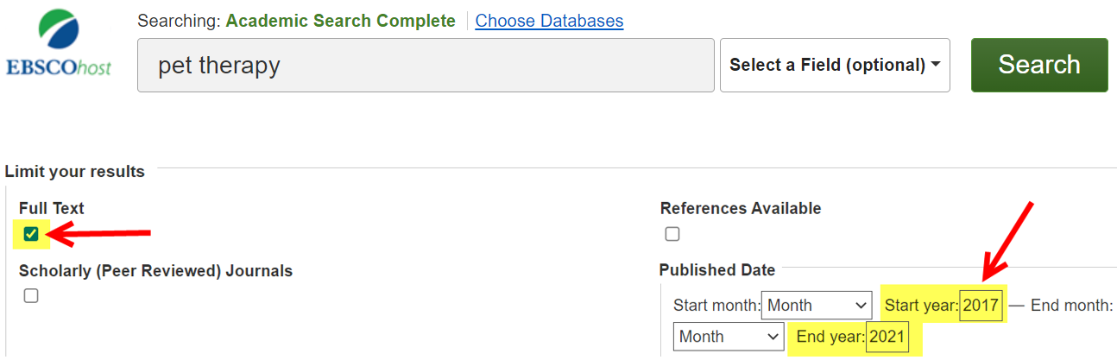
Created by Reynolds Community College Libraries. This work is licensed under a Creative Commons Attribution-NonCommercial-ShareAlike 4.0 International License.
Last updated 5/20/2021.

    - When the articles search results screen appears, click on the title of each of the first 5 articles links and briefly review the articles found.
    - When reviewing the articles click on Cite from the Tools menu on the right. Notice each citation style’s format. (e.g., APA, MLA, etc.)
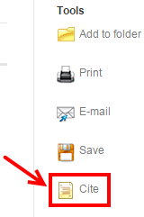

- Compare results from Google & the Academic Search Complete database
Checkmark the correct answer for each of the following questions:
- Which resource includes a variety of search options to retrieve more relevant results?
☐ Google ☐ Database ☐ Both ☐ Neither

- Which resource includes ads?
☐ Google ☐ Database ☐ Both ☐ Neither

- Which resource retrieves more full-text journal and magazine articles?
☐ Google ☐ Database ☐ Both ☐ Neither

- Which resource is best for college level research?
☐ Google ☐ Database ☐ Both ☐ Neither

- Did any of the web pages you reviewed from your Google results feature an automatic citation tool like the Cite tool in Academic Search Complete?
☐ Yes ☐ No

