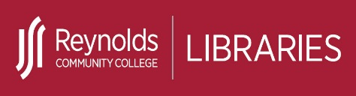 | Obtain a Full-Text Article or Book | 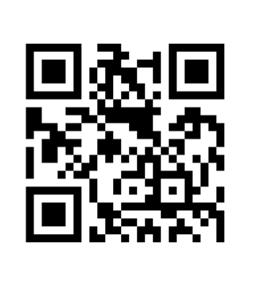
Locating Full-Text Articles:
If you have a journal, magazine or newspaper article citation (e.g., author/s, article title, periodical title, date of issue) and would like to locate the full text article, follow these steps:
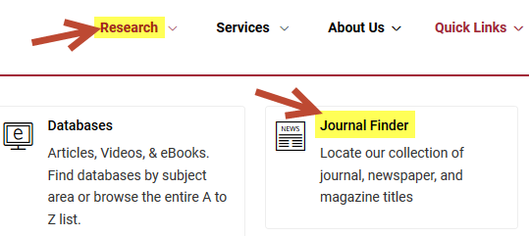
- From the Reynolds Libraries home page at library.reynolds.edu click on Journal Finder from the Research menu.

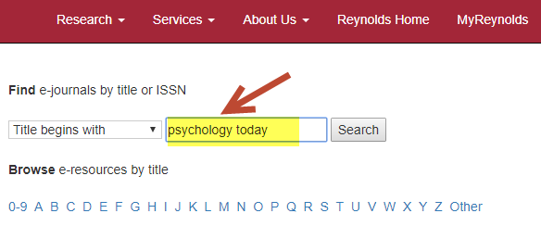
- When the Journal Finder page appears, enter the name of the journal, magazine or newspaper in the search box. Make sure to type in the name of the periodical title (e.g., Newsweek, Psychology Today) and NOT the article title. Press the <Enter> key or click on Search to execute the search.
- The Journal Finder results list will indicate whether the journal, magazine or newspaper is available online through any of Reynolds Libraries databases and provide the links to the databases. It will also indicate whether a periodical title is available in print at any of the three campus libraries.

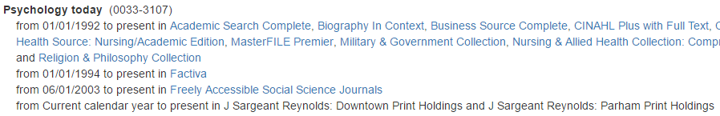

Created by Reynolds Community College Libraries. This work is licensed under a Creative Commons Attribution-NonCommercial-ShareAlike 4.0 International License.
Last updated 7/05/2019.

Obtaining Books from Other Libraries:
If you have a book citation (e.g., author/s, title, publisher, publication date), and would like to borrow a book from a local library, follow these steps:
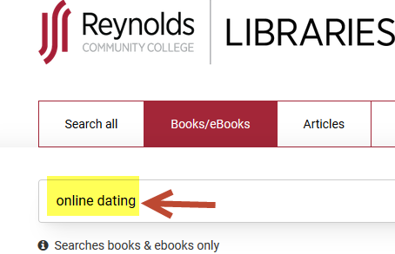
- First check to see if Reynolds Libraries owns the book. Go to the Reynolds Libraries home page at library.reynolds.edu and enter your search terms in the search box.

- If Reynolds Libraries does not own the book, go to http://www.worldcat.org to see what local libraries own the book. A Reynolds librarian will also be happy to assist you.
- You can go in person to borrow books from academic libraries throughout the state of Virginia who are members of VIVA’s Cooperative Borrowing Program (e.g., Virginia Commonwealth University, University of Richmond).
Interlibrary Loan Request (ILL):
Use Reynolds Libraries Interlibrary Loan Service if:
- An article is not available online through Reynolds Libraries databases or in print.
- A book is not available at Reynolds Libraries, a local library or it is inconvenient for you to go in person to borrow the book from a local library.
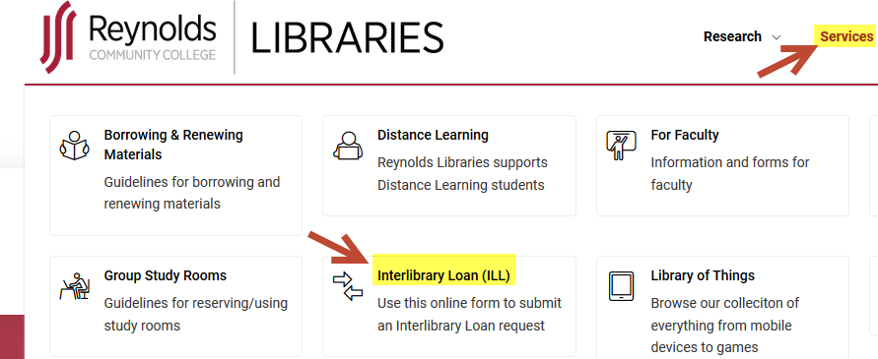
- To access the online Interlibrary Loan Request form , go to Reynolds Libraries home page at library.reynolds.edu then click on Interlibrary Loan from the Services menu.

- Articles or books can take up to 2 weeks to arrive, so please plan ahead. Articles will typically be delivered via email. Books will be delivered by postal mail to the campus library you specify on the request form. Reynolds Libraries staff will contact you when the book is in.

