Off-Campus Access to the
Library Databases

Reynolds Libraries provides off-campus access to database collections with full-text journal, magazine, and newspaper articles as well as eBooks, audiobooks and streaming videos. The guide below outlines the two main ways that you can acquire access to library resources from off campus: retrieving an article from the catalog; or accessing a database/electronic resource directly from the A-Z database list

Retrieving an article from the catalog

1. Conduct a catalog search and select an article from the results list by clicking on “full text available” or the article title itself:
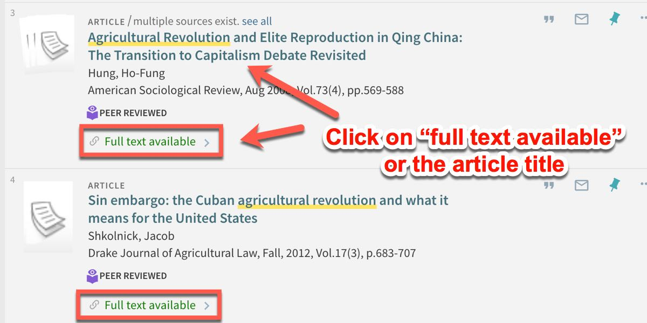
Tip: you can limit your search to full text articles only by checking the "Full Text Online" box on the right-hand side of the page.

2. Click on Database:
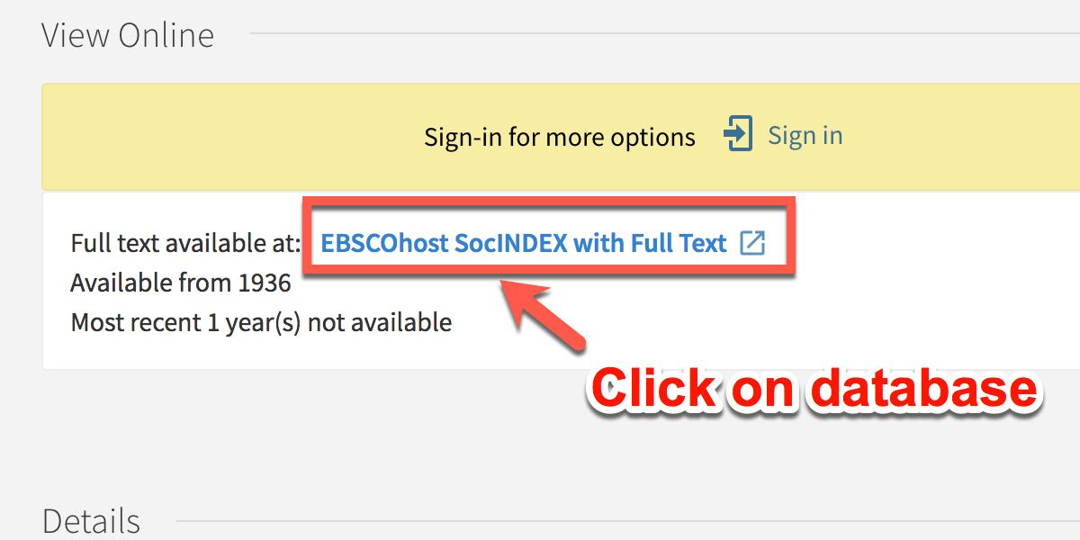
On the next page, click on the database link to access article. Note: Sometimes the article is contained in multiple databases. If for some reason you have difficulty accessing an article in a particular database, try a different one when applicable.
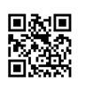

3. Enter MyReynolds login:
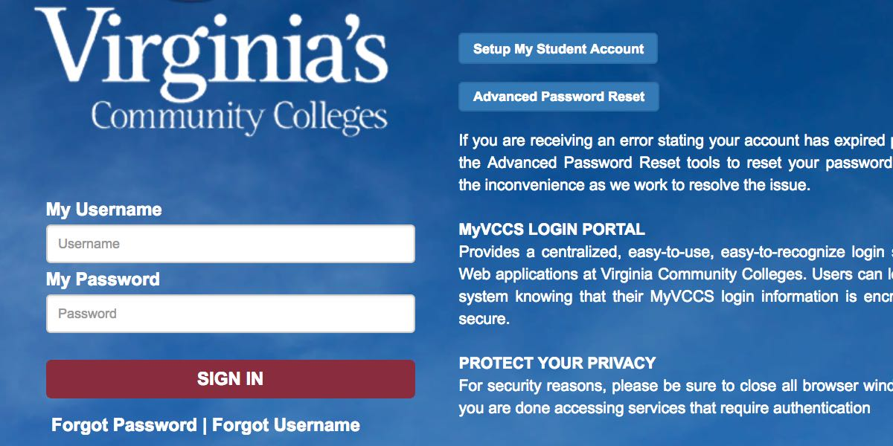
If you are off campus, the next screen to appear will be a Virginia’s Community Colleges login screen. Login with your MyReynolds (Canvas) username and password.

4. Retrieve article
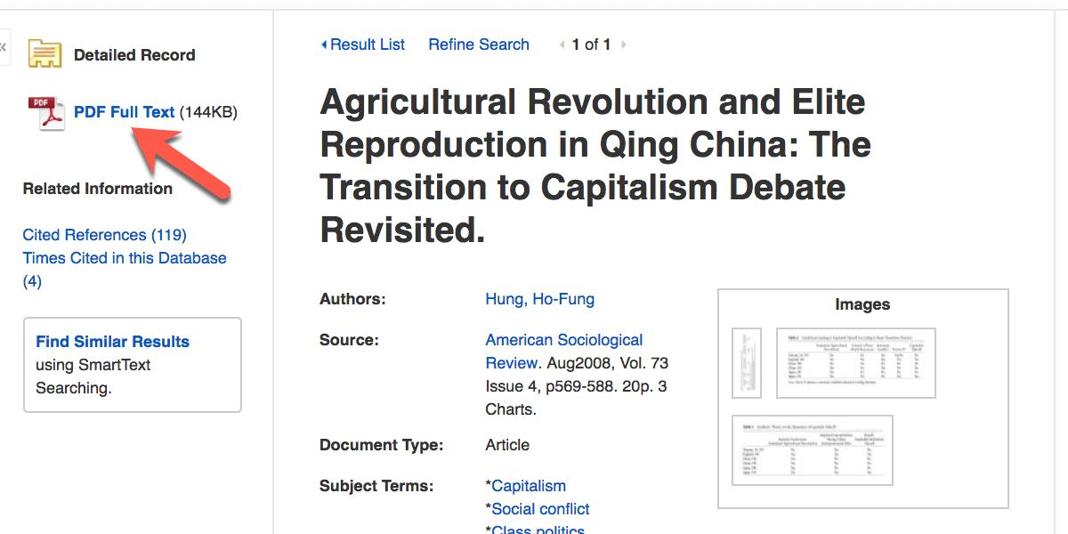
You will now be taken to the full text article. Note: On some databases you may need to click on the .pdf version in order to access the full article. Until you close your browser or logout, you should now be able to continue to retrieve library resources without having to reenter credentials.

Accessing a database/electronic resource directly from the A-Z list

1. Access Database page
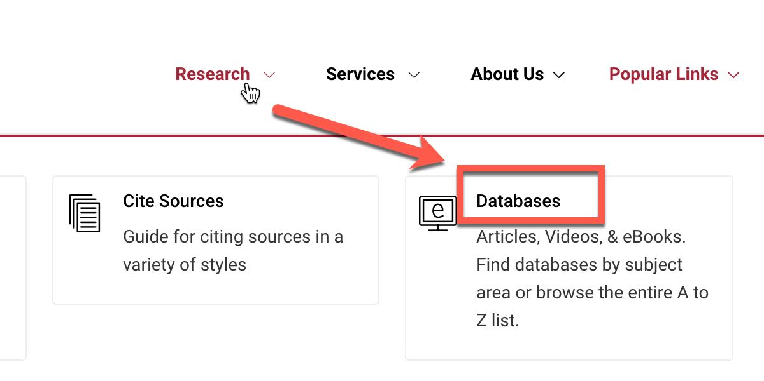From any library webpage, click on the "Databases" link found under the Research menu option.

2. Click on a database
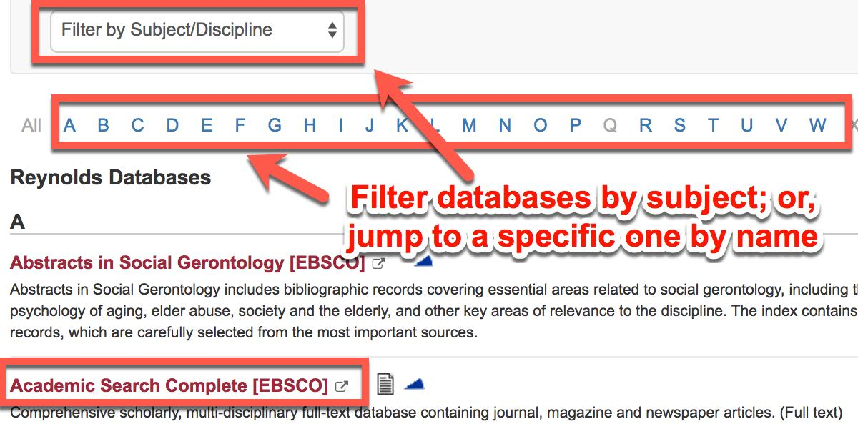

When the A-Z Databases screen appears, you can browse for databases by Subject/Discipline, or if you know the database name, select the letter of the alphabet that the database name begins with. Once located, click on the database.

Created by Reynolds Community College Libraries. This work is licensed under a Creative Commons Attribution-NonCommercial-ShareAlike 4.0 International License.
Last reviewed 7/2/2019.

3. Enter MyReynolds login

If you are off campus, the next screen to appear will be a Virginia’s Community Colleges login screen. Login with your My Reynolds (Canvas) username and password.

4. Search Database
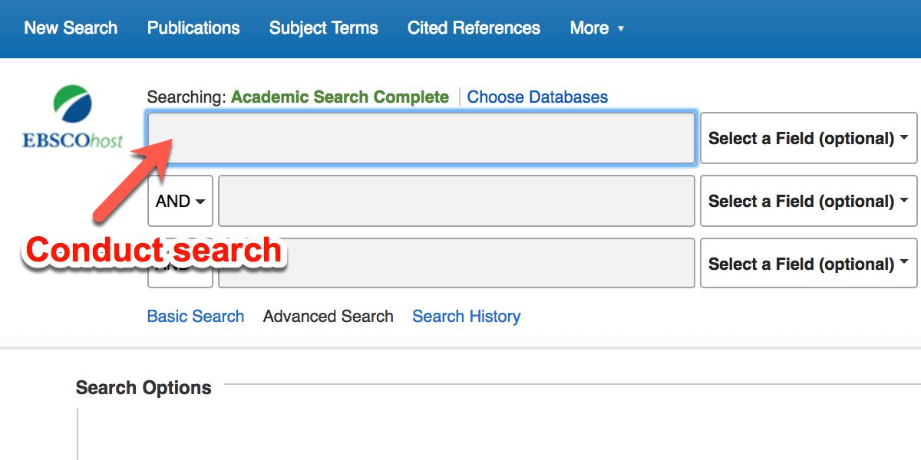
Conduct a search in the database.

