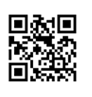

**Scholarly Journals vs.**

**Popular Magazines**

Instructors often make assignments that require the use of articles from scholarly or professional trade journals. The terms peer-reviewed, refereed, academic, or research are also used. It is often difficult, especially when using online databases or the Internet, to recognize and decide what an appropriate article is. This handout provides general guidance in recognizing the difference between scholarly journal articles and popular magazine articles.

# jabnormalpsych

# CHARACTERISTICS OF SCHOLARLY JOURNALS

* Purpose - Report on original research or experimentation.
* Articles are usually lengthy.
* Articles usually have cited references at the end.
* Usually illustrated by graphs, charts, or diagrams.
* 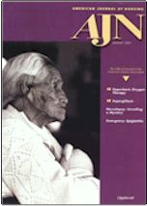Usually contain an abstract, problem statement, and methodology.
* Use vocabulary requiring some knowledge of the subject.
* Written by and geared towards scholars, researchers, or professionals.
* Often published by a professional organization or university.
* Usually published on a monthly or quarterly basis.
* Reviewed by panel or board.
* Contain few advertisements.

Examples of **scholarly journals** are:

## Psychological Reports, Journal of Marriage and the Family, American Journal of Nursing, Studies in Philosophy and Education, American Historical Review, Nature, New England Journal of Medicine

## EBSCOhost Databases:

## To search for scholarly articles only, checkmark the box next to Scholarly (Peer Reviewed) Journals from the Limit/Refine your results menu.

## JSTOR and Project Muse Databases:

## Some databases, such as JSTOR and Project Muse, provide access to scholarly journal articles only.

 *Created by Reynolds Community College Libraries. This work is licensed under a Creative Commons Attribution-NonCommercial-ShareAlike 4.0 International License. Last updated 7/22/2019.*



[](http://share.reynolds.edu/srmishc/PhotoGallery.asp?ProductCode=TIMEMAGAZINE)

## CHARACTERISTICS OF POPULAR MAGAZINES

* Articles are usually short.
* Articles seldom have cited references at the end.
* Frequently illustrated with glossy or color photographs.
* 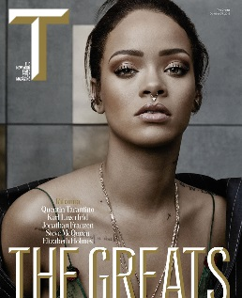Usually written by staff or freelance writers. Many times unsigned.
* 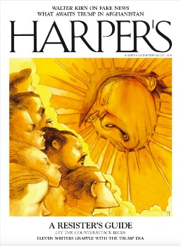Purpose - entertainment and information.
* Contain no abstract, problem statement, or methodology.
* Use simpler vocabulary. Written for the general public.
* Published by for-profit companies.
* Usually published on a weekly or monthly basis.
* Not peer-reviewed.
* Contain many advertisements.

Examples of **popular magazines** are:

*Time, Psychology Today, Atlantic, People Weekly, ScienceNews, New Leader, Glamour, New Yorker, Forbes, American Heritage,* *Natural History*

EBSCOhost Databases:

To search for magazine articles only, from the results list, click on Magazines from the *Source Types* menu on the left.

Journal Finder: Another way to search for magazines and other periodicals are to use the Journal Finder. Click on the word Research under the red banner at the top of the screen, and then click Journal Finder on the left-hand side. Enter the name of the magazine you are looking for in the search box and click the link to the date you need.