Scholarly Journals vs. Popular Magazines Worksheet

Part I
You will need to use the Academic Search Complete database to complete Parts I & II.
- From the Reynolds Libraries home page at http://library.reynolds.edu, move your mouse over Quick Links located near the upper right side of the screen. When the Quick Links menu appears, select Academic Search Complete. If you are completing this worksheet from off-campus, a Virginia’s Community Colleges login screen will appear. Use your My Reynolds username and password to access the Academic Search Complete database.
- When the Academic Search Complete search screen appears, click on the Publications link from the menu located near the top of the screen.
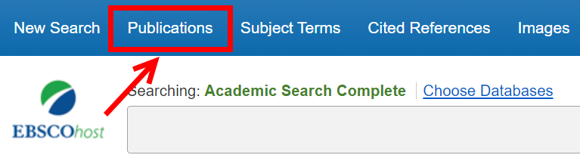
- When the Publications screen appears, type american journal of public health in the Browsing: Academic Search Complete -- Publications search box. Press the <Enter> key or click on the Browse button to execute the search.
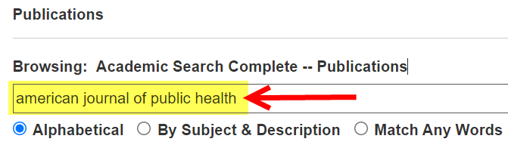
- When the next screen appears, click on the title, American Journal of Public Health.
- When the American Journal of Public Health screen appears, click on any recent year link (e.g., +2021, +2020) located near the right side of the screen. You will also need to select an issue for that year.
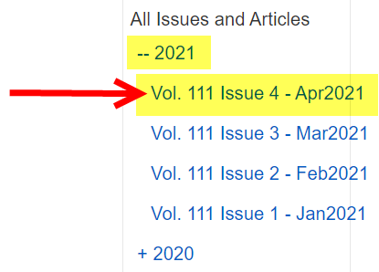
- When the search results screen appears, review at least 5 articles from the issue and answer the questions in the chart on the next page under the American Journal of Public Health column. Choose either HTML Full Text or PDF Full Text to access and review the complete article.
Created by Reynolds Community College Libraries. This work is licensed under a Creative Commons Attribution-NonCommercial-ShareAlike 4.0 International License.
Last updated 5/21/2021.

Part I - (continued)
- Perform a Publication Search for Better Nutrition using the same steps as above.
Check the box next to the correct answer for each question for both American Journal of Public Health and Better Nutrition.
American Journal of Public Health  Most articles are: | Better Nutrition  Most articles are:
☐ Lengthy - OR - ☐ Short | ☐ Lengthy - OR - ☐ Short
Author/s listed?  ☐ Yes - OR - ☐ No | Author/s listed?  ☐ Yes - OR - ☐ No
Audience written for:  ☐ Scholarly - OR - ☐ General | Audience written for:  ☐ Scholarly ☐ General
Reference listed at end of article?  ☐ Yes – OR – ☐ No | Reference listed at end of article?  ☐ Yes - OR - ☐ No
Type of article?  ☐Scholarly journal  ☐ Popular magazine | Type of article?  ☐ Scholarly journal  ☐ Popular magazine

Part II
- Using the Academic Search Complete database, perform a search on any topic.
- When the search results screen appears, review the results and select two articles - one scholarly & one popular.
- When the Detailed Record screen for each article appears, click on Permalink from the Tools menu located near the right side of the screen.
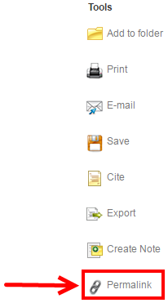

- When the Permalink window appears above the article title, copy and paste the permalink in the text boxes provided below.
Permalink for scholarly journal article: Enter Permalink
Permalink for popular magazine article: Enter Permalink

Part III
Review the two (2) article citations listed below. Check the box next to the correct answer to indicate whether the citation comes from a scholarly journal or a popular magazine.
1. Fletcher Jr, William L. “Netflix and Quill: Using Access and Consumption to Create a Plan for Taxing the Cloud.” William & Mary Law Review, vol. 58, no. 3, Feb. 2017, pp. 1029–1066.
☐ Scholarly journal - OR - ☐ Popular magazine
2. Moscaritolo, Angela. “In Going Global, Netflix Curbs Proxy Use.” PC Magazine, Feb. 2016, pp. 19–20.
☐ Scholarly journal - OR - ☐ Popular magazine

