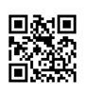
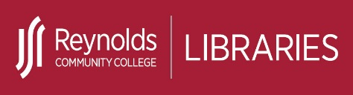
Evaluate Sources

Subject experts and publishers evaluate most library resources including articles and books available in print and online through library database collections. However, on the open web including social media sites, ANYONE can publish their opinions and ideas. Did you know there are over one billion websites on the open web and NO standards exist to ensure what you find is reliable or accurate?

It is important to think critically about the resources you find both online and in print to determine if a resource is credible. The checklist below will help you identify credible resources to use for college research assignments as well as for making important decisions in all aspects of your personal and professional life.
Evaluation Criteria Checklist – The 5 W’s
Who? | - Who is the author? Is an author listed?  - What are the author's credentials?  - Does the author's education or experience qualify them as an authority on the topic they are writing about?  - What institution or organization is the author affiliated with?  - Is contact information listed for the author?  - Who is the intended audience? Is the source written for professionals or the general public?
What? | - What is the purpose of the information - to educate, entertain, inform, persuade, sell?  - What type of resource is it? (e.g., advertisement, blog, journal, magazine or newspaper article)  - What information in this resource should I use in my assignment and how should I use it?  - Is the information objective or does it contain any biases?  - Are there any advertisements or sponsors?
Where? | - Where does the information come from? (e.g., database, organization, sponsor, .edu, .gov, .org, .com)  - Where can I look to find out more about the publisher or sponsor?  - Where can I use this resource in my assignment?
When | - When was the resource published or last updated? Is a publication date listed?  - Is the information timely or is it outdated?  - Does my topic require current information? (e.g., science or technology topic)  - Will older resources be acceptable or preferred? (e.g., history topic or primary source)  - Do the links on the webpage or website still work?
Why? | - Why should I use this resource for my assignment?  - Why is this resource relevant to my thesis or topic?  - Why is this resource better to use in my assignment than other resources?  - Does the source add new information to the topic I am researching or does it simply repeat or summarize other perspectives?

Created by Reynolds Community College Libraries. This work is licensed under a Creative Commons Attribution-NonCommercial-ShareAlike 4.0 International License.
Last updated 7/13/2023.

