Evaluate Sources Worksheet

Choose ANY topic to research. Jot down some keywords below that describe your topic.
Click or tap here to enter your keywords.
- Google
- Use the keywords you listed above to perform a Google search at https://www.google.com.
- Select one (1) website from your Google search results to evaluate.
Website URL: Click or tap here to paste the URL.
- Use the 5 W’s criteria/questions listed on the corresponding Evaluate Sources handout to evaluate this website.

Who? Click or tap here to enter answer.

What? Click or tap here to enter answer.

Where? Click or tap here to enter answer.

When? Click or tap here to enter answer.

Why? Click or tap here to enter answer.

- Would you use this web site for a college research assignment (Check one)?
Yes ☐ No ☐
Why or why not?
Click or tap here to explain why or why not.

- Academic Search Complete Database
- Go to the Reynolds Libraries homepage at http://library.reynolds.edu. Click on Academic Search Complete from the Quick Links menu located near the upper right side of the homepage. If you are off-campus, you will be prompted to login with your My Reynolds username and multifactor authentication (MFA).
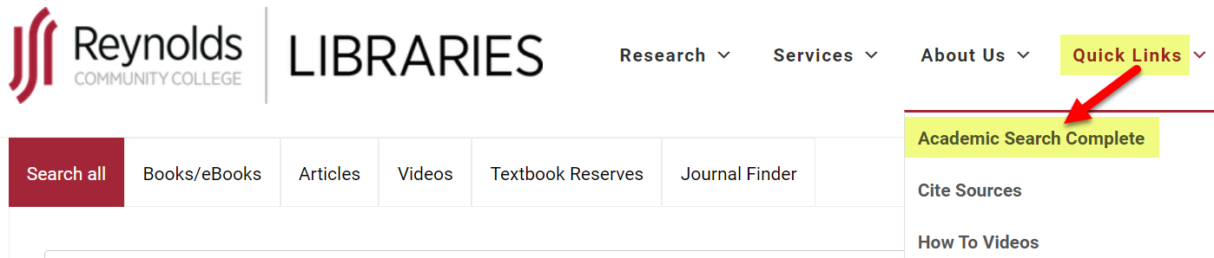

Created by Reynolds Community College Libraries. This work is licensed under a Creative Commons Attribution-NonCommercial-ShareAlike 4.0 International License.
Last updated 7/13/2023.

- Academic Search Complete Database (cont’d)
- When the Academic Search Complete database search screen appears, type in the SAME keywords you used for your Google search. When the results list appears, use the Limit To menu located on the left side of the results to limit your search to Full Text, Peer Reviewed articles published within the last 5 years.
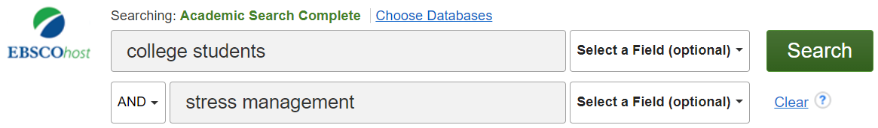
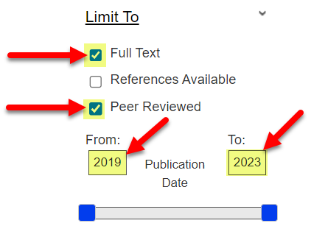
- Select one (1) article from your Academic Search Complete search results to evaluate.
Article Permalink (When viewing the Detailed Record for the article, click on the Permalink option from the Tools menu on the right. The permalink will then appear above the title): Click or tap here to paste the Permalink.

- Use the 5 W’s criteria/questions listed on the corresponding Evaluate Sources handout to evaluate this article.
Who? Click or tap here to enter answer.

What? Click or tap here to enter answer.

Where? Click or tap here to enter answer.

When? Click or tap here to enter answer.

Why? Click here to enter text.

- Would you use this article for a college research assignment (Check one)?

Yes ☐ No ☐

Why or why not?
Click or tap her to explain why or why not.

