Cite MLA Style Worksheet

Use the the three (3) sources on page 1 and 2 of this worksheet to create a Works Cited list in MLA style on page 3. Remember to organize sources alphabetically, use Times New Roman 12, use double spacing and use hanging indents.
Print book by one author
Link to library catalog record:
https://vcc-srl.primo.exlibrisgroup.com/permalink/01VCC_SRL/gr4s53/alma9927734289004393

News article from the open web
Link to news article:
https://www.reuters.com/legal/us-supreme-court-upholds-law-against-encouraging-illegal-immigration-2023-06-23/

Created by Reynolds Community College Library. This work is licensed under a Creative Commons Attribution – NonCommercial - ShareAlike 4.0 International License.
Last updated 7/13/2023.

Journal Article Retrieved from a Database with Three Authors – Includes DOI #
Link to journal article: http://ezjsrcc.vccs.edu/login?url=https://search.ebscohost.com/login.aspx?direct=true&db=a9h&AN=151259527&site=ehost-live&scope=site

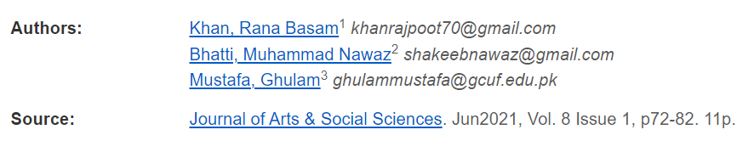
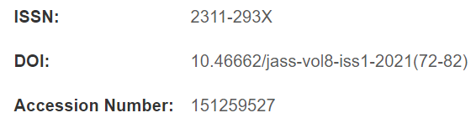

Works Cited

