
Info To Go

Resources:
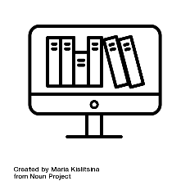
- Access over 150 library databases
- Use your MyReynolds login for off-campus access
- Online popular & scholarly articles
- eBooks & print books
- Streaming films & DVDs

Research Help:

- 24/7 Chat
- In-person research assistance
- Call DTC at 804-523-5211 or PRC at 804-523-5329
- Email: library@reynolds.edu

Workshops:

- Register from the Reynolds Libraries Workshops page
- Workshops on finding resources, citing resources, evaluating resources, and using Canvas

Printing and Scanning:

- Printing: 10¢ for black and white / 30¢ for color
- Login to PaperCut to print from your laptop
- Free scanning

Computing:
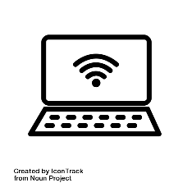
- Use PCs at the campus libraries
- Borrow laptops for 4 hours or the semester: first come, first served
- Access the Wi-Fi at any campus

And More:

- Borrow headphones, calculators & chargers
- Group study rooms
- Request books & articles from other libraries. Ask us how!


Created by Reynolds Community College Libraries. This work is licensed under a Creative Commons Attribution-NonCommercial-ShareAlike 4.0 International License. Last updated on 10/11/2025.

