
Online Search Strategies

Below are search techniques to help you find relevant results when using the library databases.

Identify Keywords
Create a list of keywords associated with your topic and keep them with you throughout the research process.
- Write down your topic: What effect does the extraction of fossil fuels have on the environment?
- Important keywords from your topic: extraction, fossil fuels, environment
- Synonyms or other related words: mining, drilling, coal, crude oil, gas, ecosystem, biosphere

Now you have generated a useful list of keywords for finding resources!
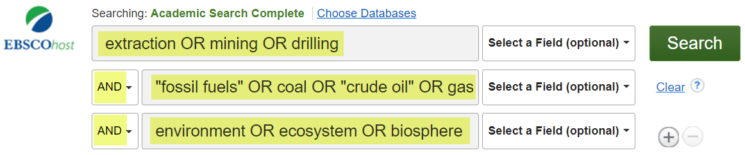

Exact Phrase Searching
To look for an exact phrase, type your phrase within quotation marks (" "). The results will contain the exact words in the quotation marks.
Example: “fossil fuels”

Truncation to Expand Your Search
Using an asterisk (*) or question mark (?) at the end of a root word (known as truncation or stemming), allows you to retrieve results containing any form of the root word.
Example: drill* will find drill, drills, driller, drillers, drilling

Note:
Most databases use the asterisk (*) as the truncation symbol. Check the Help link of the database you are using for the truncation symbol.


Created by Reynolds Community College Libraries. This work is licensed under a Creative Commons Attribution-NonCommercial-ShareAlike 4.0 International License.
Last updated on 12/03/2025.

Boolean Operators to Narrow or Broaden Your Search
Boolean searching is based on connecting keywords with three basic operators: AND, OR and NOT.
AND  The database will only retrieve resources that contain both words. This will NARROW your search and DECREASE search results.  Example: school AND crime | 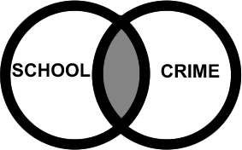
OR  The database will retrieve resources that contain at least one of these words. This will BROADEN your search and INCREASE search results.  Example: baby OR infant | 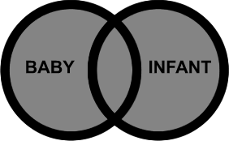
NOT  Type NOT before a keyword to exclude that word from your search. Use NOT when you are searching for a keyword that may have multiple meanings.  Example: bat NOT baseball | 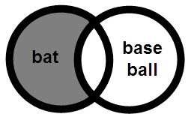
Combining Boolean Operators  Use parentheses ( ) to keep combination searches in order. In the example below, resources retrieved will contain the word law and at least one of the words in parentheses.  Example: law AND (ecstasy OR mdma) | 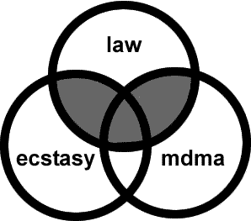

Still need help? Ask a librarian!
library.reynolds.edu

